SONG EXERCISE

Imagine
John Lennon
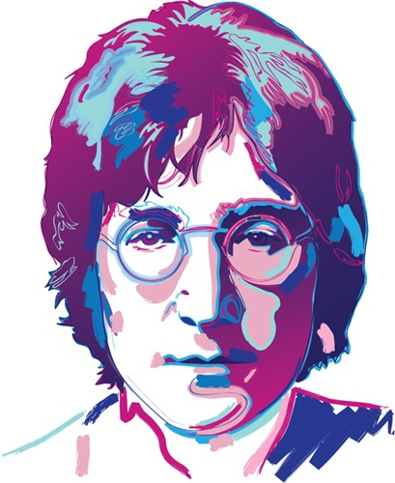

- Listen to the first part of the song and cross out any extra words.

Imagine there's no beautiful Heaven
It's easy if you try hard
Absolutely no hell below us
Above us only the blue sky
Imagine all the people in the world
Living only for today

- Listen to the second part of the song and circle the word you hear.

Imagine there's no boundaries / countries
It isn't difficult / hard to do
Nothing to kill / view or die for
And no religion / repetition too
Imagine / Immerse all the people
Living life in love / peace

- Listen to the chorus and put the sentences in order.

( ) I hope someday you'll join us
( ) But I'm not the only one
( ) And the world will be as one
( ) You may say that I'm a dreamer

- Listen to the last part of the song and fill in the blanks with words from the box. There are some extra words.
connections getting greed hunger hungry neighborhood
ponder sharing wonder possessions brotherhood

Imagine no ________________________
I ________________________ if you can
No need for ________________________ or ________________________
A ________________________ of man
Imagine all the people
________________________ all the world

By Lilian Marchesoni

